# COMS-280 Final Project

## Functional Demonstration

Program start (list of account options)

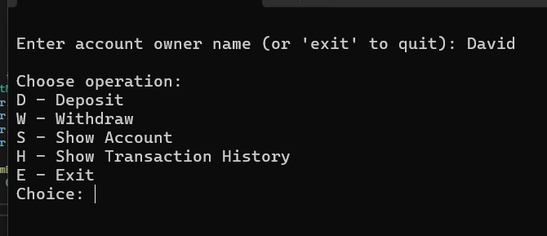

Display Account Details (Polymorphic Behavior)

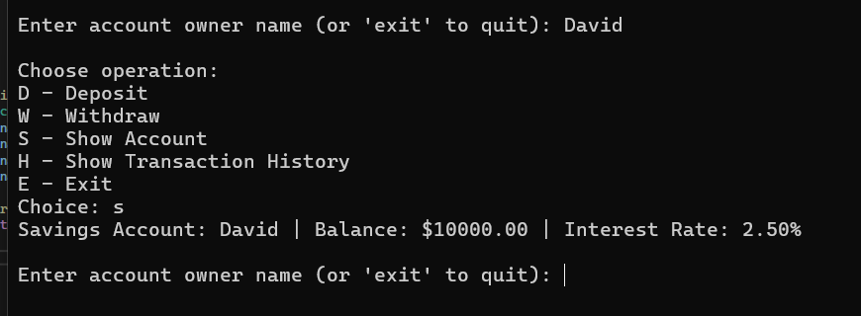

Deposit Transaction

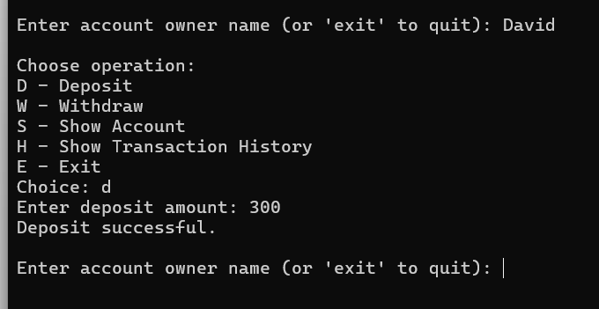

Transaction History Now Includes:

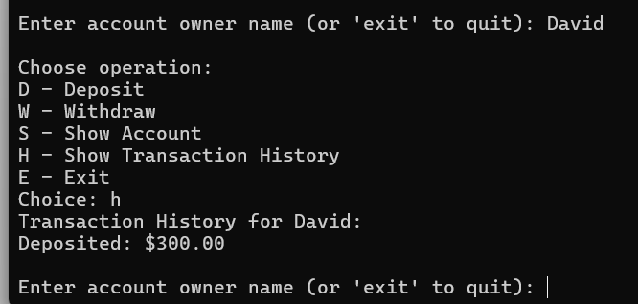

Withdraw Funds (Successful)

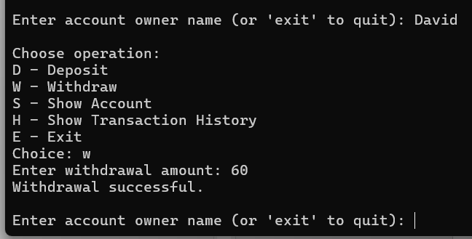

Transaction History Now Includes:

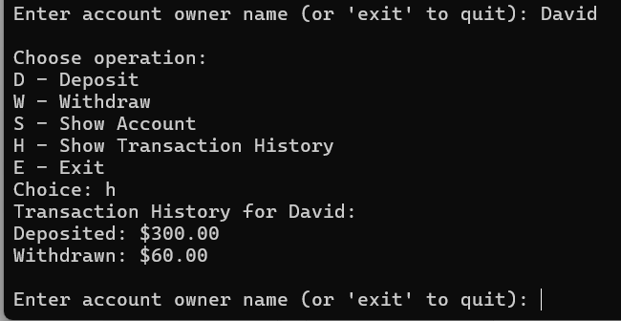

Withdraw More than Balance (Error Handling):

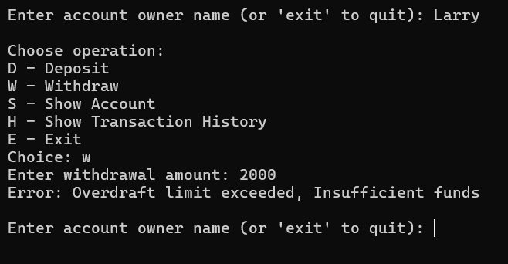

Checking Account Overdraft Behavior (Larry’s account balance is 1000 plus 500 overdraft limit):

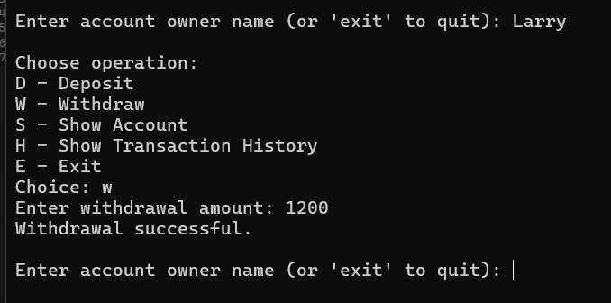

Viewing Transaction History:

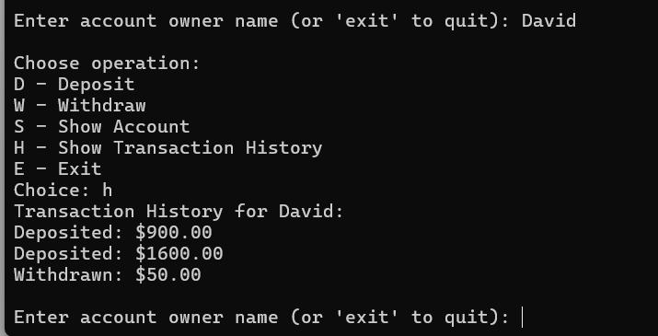

Exiting the Program:

